Foreign Language Centre
________________________________________
The Foreign Language Centre at Warsaw University of Technology
would like to invite students to take
an exam at: | B1 | level in: | English  German  French  Italian  Russian
GENERAL INFORMATION:
- The written part will take place on Thursday, June 01, 2017 at 4.00 p.m.
- The oral part will take place on Wednesday, June 07, 2017 at 4 p.m.
- The B1 Exam in General English, German, French, Italian and Russian is open to all WUT students who have already passed their B2 exam in another language.
THE EXAM
- More detailed information about the exam can be found on our website www.sjo.pw.edu.pl
- After passing the exam students can receive a certificate issued by the Foreign Language Centre at Warsaw University of Technology.

HOW TO REGISTER
The registration is open from
May 10 to May 29, 2017
Students should register in room 419 in the WUT Main Building. The office is open on Monday and Wednesday from 9 a.m to 3 p.m and on Tuesday, Thursday and Friday from 9 a.m to 1 p.m.
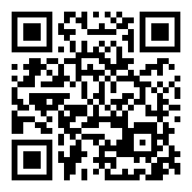
The fee for the exam is 60 zlotys. Details concerning methods of payment will be given to the candidates at the time of registration. The final list of students registered for the exam will be posted on SJO webpage on May 30, 2017.
For more information please write to
e.chrzczonowska@sjo.pw.edu.pl

